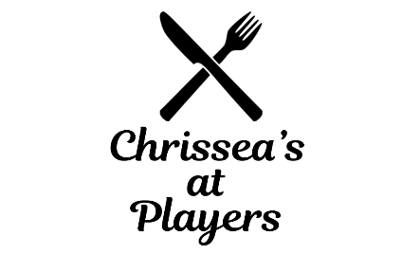

DRINK MENU
Bottomless Coffee: $2.75 | Juice: $3.10
Stash Tea (Variety): $3.25 | Bottled Pop/Gatorade: $3.50
Red Rose/Green Tea: $2.75 | Milk (2%): $2.65
Hot Chocolate : $3.00 | Chocolate Milk: $2.75
 | Bottled Water: $2.70

BEER
Domestic: $6.25 (Budweiser, Bud Light, Coors Light, Coors Original/Banquet, Kokanee, Molson Canadian, Michelob, Sleeman, MGD, Alexander Keith’s)
Imported: $7.25 (Heineken, Stella, Corona) Red Horse (Tall can): $7.75
Torque (Tall cans: Red Line IPA, Hazy Whaler, Round About): $7.75
Torque (Regular cans: What the Helles, Torque Blonde): $6.25
DRAFT (Torque: Witty Belgian and What the Helles)
Mug (10 oz): $4.25 Pint (16 oz): $6.25 Pitcher: $20.00
NON-ALCOHOLIC BEER
Bud Zero: $5.00
COOLERS: $6.75
Mike’s Hard Lemonade, Hard Lime, Black Cherry, Smirnoff Ice, White Claw, Socialite, Twisted Tea

WINE (Jackson-Triggs: Sauvignon Blanc, Cabernet Sauvignon)
Glass (6 oz): $7.75 Glass (9 oz): $11 Bottle: $32 ½ Litre: $17

(Copper Moon, Pinot Grigio, Cabernet Sauvignon)
Glass (6 oz): $6.75 Glass (9 oz): $9.50 Bottle: $27 ½ Litre: $15

COCKTAILS/SHOTS REGULAR
Hi-balls Single: $6.50
Doubles: $9.50
Premium:
Single: $7.50
Doubles: $10.75
Premium Alcohol: Grey Goose, JP Wisers, Crown Royal, Jack Daniels, Jose Cuervo, Bombay Sapphire, Kahlua, Baileys, Amaretto, Red Label, E & J Blue Brandy, Spiced Rum
Regular Alcohol: Alberta Pure, Lambs, Captain Morgan, Bacardi, Smirnoff, Fireball, Beefeater Gin
Extra Premium
Single: $12.50
Doubles: $16.00
Extra Premium: Remy Martin Cognac, Hennessy, Chivas Regal, Glenfiddich, Johnnie Walker Black

**PRICES SUBJECT TO APPLICABLE TAXES**

